主题：废纸回收

题型：流程图

The chart below shows the process of waste paper recycling.

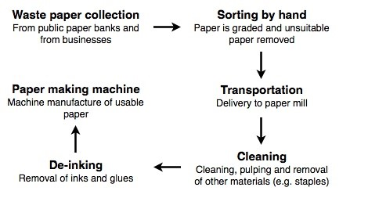

满分范文：

The chart below shows the process of waste paper recycling.

The flow chart shows how waste paper is recycled. It is clear that there are six distinct stages in this process, from the initial collection of waste paper to the eventual production of usable paper.

At the first stage in the paper recycling process, waste paper is collected either from paper banks, where members of the public leave their used paper, or directly from businesses. This paper is then sorted by hand and separated according to its grade, with any paper that is not suitable for recycling being removed. Next, the graded paper is transported to a paper mill.

Stages four and five of the process both involve cleaning. The paper is cleaned and pulped, and foreign objects such as staples are taken out. Following this, all remnants of ink and glue are removed from the paper at the de-inking stage. Finally, the pulp can be processed in a paper making machine, which makes the end product: usable paper.